***Assignment –7***

Summarizing Data with Aggregate Functions.

1. Write a query that counts all orders for October 3.

Ans 1)

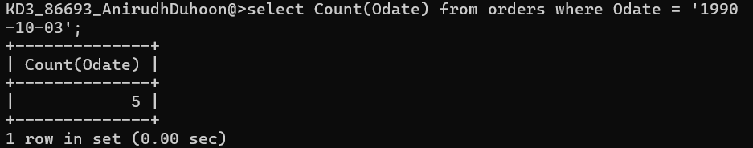

1. Write a query that counts the number of different non-NULL city values in the Customers table.

Ans 2)

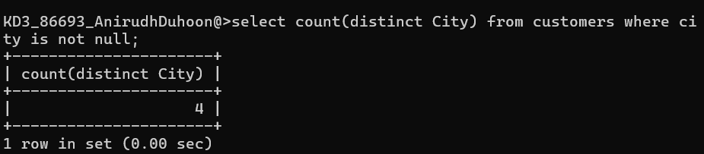

1. Write a query that selects each customer’s smallest order.

Ans 3)

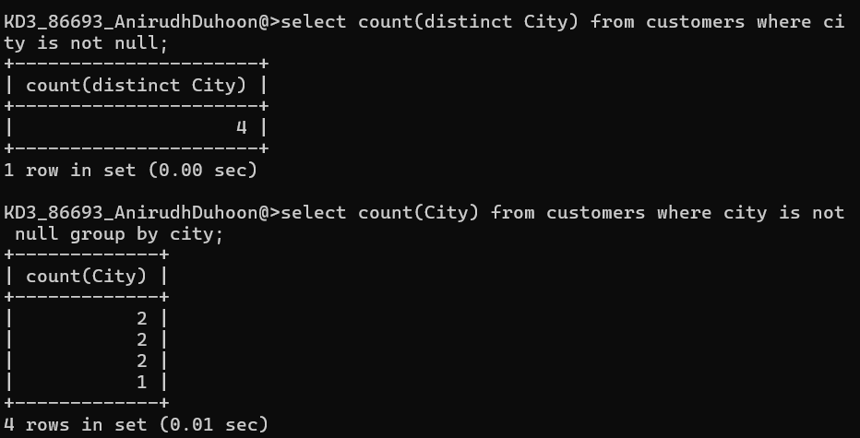

1. Write a query that selects the first customer, in alphabetical order, whose name begins with G.

Ans 4) 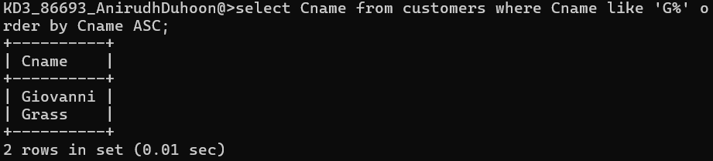

1. Write a query that selects the highest rating in each city.

Ans 5)

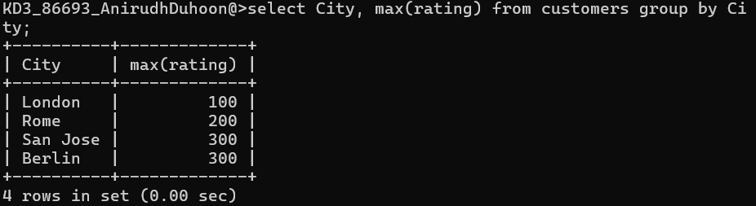

1. Write a query that counts the number of salespeople registering orders for each day. (If a salesperson has more than one order on a given day, he or she should be counted only once.).

Ans 6)

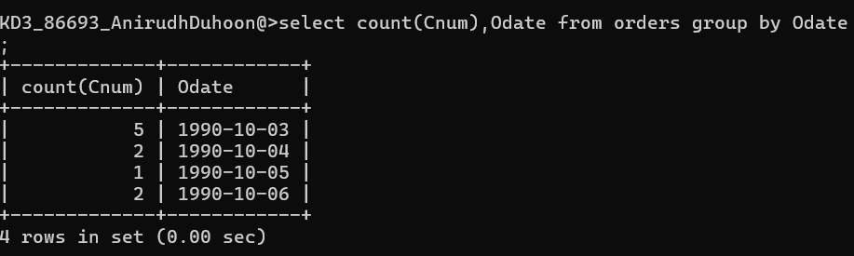

*Sameer Dehadrai* Page: 1